Stress-Induced Birefringence Measurement for Crack Detection
in Bessel Beam Laser-Drilled Glass

Nakcho Choi, Jeongjin Park, and Seongjun Lee

Mobile Display Division, Samsung Display Co., Ltd., Giheoung-gu, Yongin-City, Gyeonggi-Do, Korea

Tel.:82-31-8151-3885, E-mail: water.choi@samsung.com

This study presents a non-destructive inspection methodology for detecting latent defects in laser-processed glass used in Under Display Cameras (UDC) and Glass Core Substrates (GCS). Building upon our previous research on microscopic stress-induced retardation in amorphous layers, we apply liquid crystal retardation sensing to visualize stress fields during laser drilling. We demonstrate that peak stress accumulation occurs at partial depths, serving as a precursor to cracks, enabling yield improvement for both advanced displays and semiconductor packaging.

1. Introduction

The convergence of display and semiconductor technologies has created unprecedented demands for glass-based manufacturing, specifically for Under Display Cameras (UDC) and Glass Core Substrates (GCS) [1, 2]. While glass offers superior dimensional stability and electrical insulation compared to traditional substrates, its inherent brittleness presents significant process control difficulties. High-energy pulsed laser modification, required for these microscopic apertures, induces complex residual stress fields. These stresses serve as nucleation sites for micro-cracks, which often remain invisible to conventional microscopy until catastrophic failure occurs during subsequent processing. Our research group previously investigated the relationship between mechanical stress and optical anisotropy in thin-film amorphous materials [3]. We demonstrated that microscopic stress mismatches induce measurable phase retardation, a phenomenon we termed Microscopic Stress-Induced Retardation. This work established that nominally isotropic materials exhibit detectable birefringence under localized stress fields.
The present investigation extends this principle from thin-film stacks to bulk glass substrates (hundreds of micrometers thick) subjected to high-energy laser drilling. We hypothesize that the photoelastic response can be quantitatively measured using liquid crystal retardation sensors to predict crack propagation [4]. The specific objectives are to characterize stress evolution relative to processing depth, correlate the optical slow axis orientation with crack trajectories, and demonstrate this technique as an effective in-line inspection method for yield improvement in advanced manufacturing [5].

2. Theoretical Framework and Measurement Principle

The measurement methodology exploits the photoelastic effect, whereby mechanical stress induces optical anisotropy in normally isotropic materials. When glass is subjected to laser-induced thermal shock and mechanical deformation, it develops a local birefringence characterized by different refractive indices along orthogonal principal stress directions. The magnitude of phase retardation experienced by transmitted polarized light is given by:

R = C · (σ₁ - σ₂) · d

Where R represents the phase retardation in nanometers, C is the stress-optical coefficient (approximately 3.5 × 10⁻⁶ mm²/N for soda-lime glass), (σ₁ - σ₂) represents the principal stress difference, and d is the optical path length through the stressed region.
For this investigation, we employed a spectroscopic Mueller matrix polarimeter system adapted from liquid crystal cell characterization equipment. This instrument configuration provides simultaneous measurement of two critical parameters. The retardation magnitude quantifies the intensity of residual stress accumulated within the glass matrix, while the slow axis orientation indicates the direction of maximum tensile stress. The slow axis represents the polarization direction that experiences the higher refractive index, corresponding to the principal tensile stress direction, and is orthogonal to the expected crack propagation path.
The measurement system operates across multiple wavelengths (450 nm, 550 nm, and 650 nm) to characterize the chromatic dispersion of stress-induced birefringence. This multi-wavelength approach serves two purposes: it validates that the observed signal originates from stress rather than material compositional variations, and it provides enhanced sensitivity for detecting subtle stress gradients near crack initiation sites.

3. EXPERIMENTALS

Laser processing was performed using a picosecond pulsed laser system operating at a wavelength of 1064 nanometers. The experimental design systematically varied three critical process parameters. Pulse energy was modulated across three discrete levels (designated Low (1), Mid (2), and High (3)) spanning an order of magnitude range. Spatial pitch between adjacent laser modification sites was set at either 10 or 20 micrometers to investigate stress field overlap effects. Most critically, processing depth was controlled to create samples at various stages of perforation: surface modification representing approximately 10 percent of substrate thickness, half-cut conditions at 60% (300㎛) to 80%(400㎛) percent depth, and complete through-hole perforation at 100% (500㎛ depth). The experimental conditions are shown in Table 1. The top image of the processed laser hole observed under a microscope is shown in Figure 1(a), and the cross-sectional image is shown in Figure 1(b).
For each experimental condition, retardation mapping was performed immediately following laser processing. The optical retardation was measured using the image polarimeter Axostep 20H obtained from Axometrics Inc. Transmittance, retardance, and slow axis retardance values ​​were measured at wavelengths of 450 nm, 550 nm, and 650 nm using the AxostepTM measurement equipment. Originally, this equipment was developed to analyze the slow axis, which can determine the retardation and orientation direction of liquid crystals, but it was utilized because it can accurately measure the retardation stress direction even when microscopic stress-induced retardation occurs in isotropic glass.

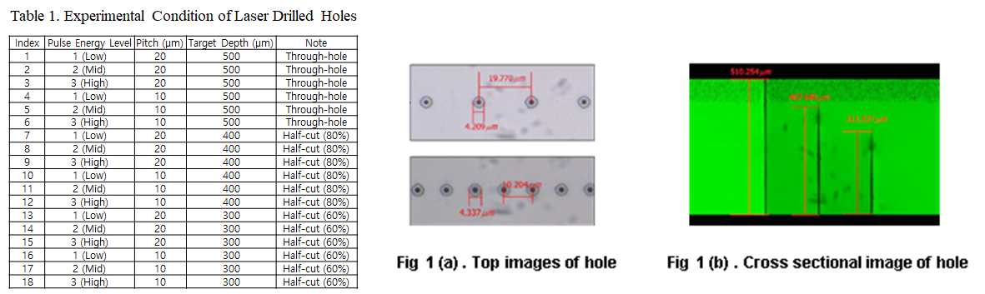
Fig 1. Optical microscope images of a glass substrate processed using a Bessel beam laser. (a) Top-view image of the processed hole. (b) Cross-sectional image of the hole, serving as a reference standard for measuring the laser processing depth.

4. RESULTS and DISCUSSION

The retardance around a hole was measured according to the pulse energy at an Axostep wavelength of 550 nm. The sample indices ranged from 1 to 3. Strong stress-induced retardation was observed around the hole, as shown in Figure 2. Figure 2 shows that when the retardance magnitude is plotted horizontally for a single hole, the retardance value increases as the pulse energy intensity increases.

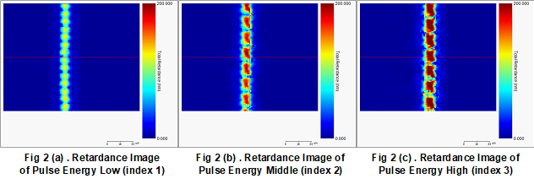
Fig 2. Measurement results of retardance around a hole as a function of laser pulse energy intensity. The data demonstrates that the magnitude of stress-induced retardation, measured at a wavelength of 550 nm, increases proportionally as the pulse energy level (Index 1 to 3) increases.

Figures 3 and 4 show the retardance measurements of three laser-drilled holes of different depths using high-energy pulses at laser hole pitches of 20 μm and 10 μm. Both graphs show that the highest retardance value is at a depth of 400 μm, followed by 500 μm and 300 μm. This indicates that stress-induced retardation increases gradually when holes are drilled with a Bessel beam laser, and then decreases as the stress is released after the hole is created through the 500 μm glass hole. Although it was not possible to quantitatively determine the damage caused by stress around the hole using an optical microscope, by using the phase difference measurement method as above, it is possible to drill a hole using a laser through precision processing, and in particular, it is possible to predict or control the occurrence of cracks around the hole.
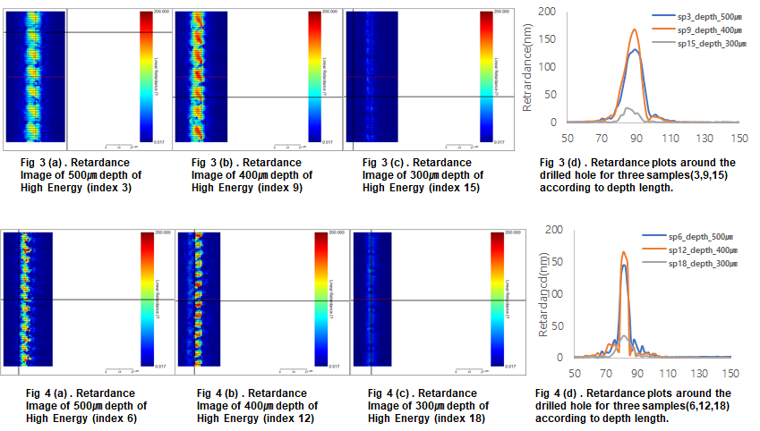
Fig 3. Comparison of retardation at varying processing depths (300, 400, and 500㎛) with a laser hole pitch of 20㎛. Peak stress accumulation is observed at a depth of 400㎛ (approximately 80% depth) prior to complete perforation (500㎛), indicating that this 'half-cut' stage represents the critical window for maximum crack initiation risk.

Figure 5(a) depicts the slow axis of retardance around a laser-drilled hole, as if it were an arrangement of liquid crystal molecules. Figures 5(b) and 5(c) illustrate the occurrence of disclination and singularities when liquid crystal molecules are aligned, which are defined numerically according to the arrangement shape. Applying this, the singularities of stress-induced retardance are depicted in Figure 5(a).[6]

Fig 4. Comparison of retardation at varying processing depths with a narrower laser hole pitch of 10 ㎛. While stress field overlap effects between adjacent holes become more pronounced due to the reduced pitch, the trend of stress distribution relative to depth remains consistent with Figure 3, exhibiting a maximum value at 400 ㎛

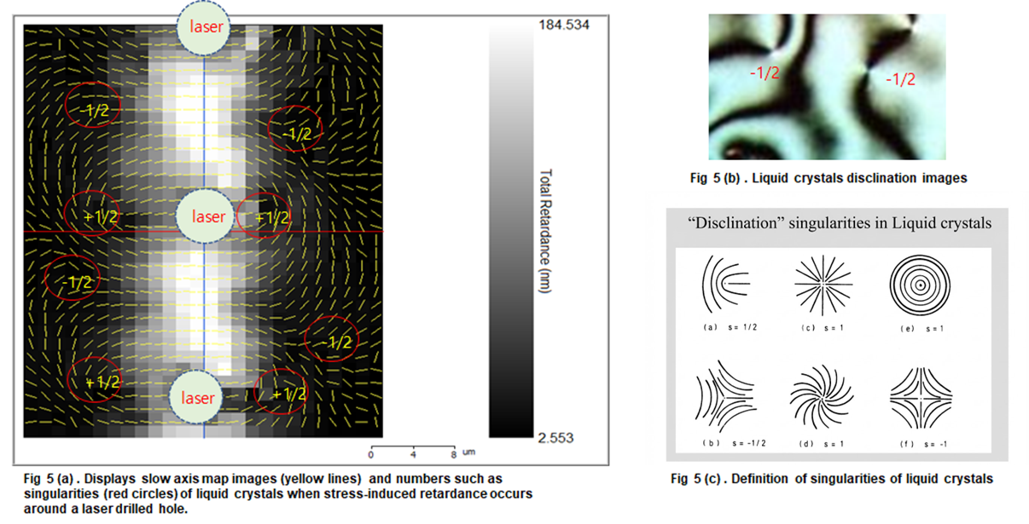
Fig 5. Analysis of the slow axis orientation of stress-induced retardation using liquid crystal alignment theory. (a) Visualization of the slow axis vector field around a laser-drilled hole. (b), (c) Application of disclination and singularity models—concepts from liquid crystal defects—to the stress field, defining points of mechanical instability where stress vectors converge or diverge.

Beyond quantifying the stress magnitude, the orientation of the optical slow axis provides critical information regarding the stress field geometry and crack propagation directionality. Our analysis reveals that the slow axis vector field around laser-processed holes exhibits characteristic patterns that directly correlate with observed fracture trajectories.
Figure 6 illustrates the validation of this correlation. Figure 6(a) presents the slow axis vector map, while Figure 6(b) shows the corresponding optical microscope image of a physical crack propagating between two adjacent laser-drilled holes. The vector field displays a distinctive symmetry, where regions of high vector density (closely spaced vectors with steep gradients) represent sites of maximum mechanical instability. By superimposing the crack trajectory (indicated by the red dotted line in Fig. 6(a)) onto the vector map, a striking correlation is observed: physical cracks propagate preferentially perpendicular to the slow axis vectors. This observation aligns with fundamental fracture mechanics. The slow axis corresponds to the direction of the maximum refractive index, which aligns with the principal tensile stress direction (σ₁). To minimize elastic energy, crack opening occurs perpendicular to this tensile stress. Consequently, the slow axis analysis successfully predicts the formation of characteristic crack patterns, as the fracture follows the path of least resistance orthogonal to the local slow axis orientation. To further investigate the fine structure of this stress distribution, a high-resolution continuous retardation scan was performed along the laser processing path, as shown in Figure 7. This visualization reveals the process history imprinted on the glass. A periodic "wave-like" modulation is observed along the vertical axis, correlating with the spatial overlap of individual picosecond laser pulses. These striations represent alternating bands of residual stress induced by rapid thermal shock cycles. Furthermore, the vector field in Figure 7 confirms that the stress is not uniform but highly anisotropic. By identifying regions where slow axis vectors converge or exhibit abrupt directional changes (singularities), manufacturers can pinpoint high-risk zones for "butterfly" cracks and implement localized laser parameter adjustments before catastrophic failure manifests.

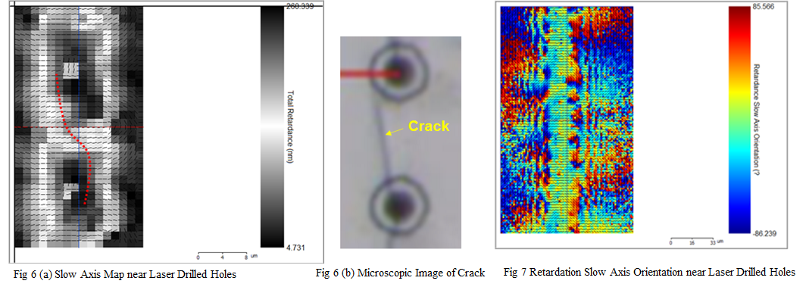
Fig 6. Validation of the correlation between the stress vector field and physical fracture. (a) Slow axis orientation map indicating the trajectory of the high-stress gradient (marked by the red dotted line). (b) Optical microscope image confirming the actual crack propagation along the predicted path between two adjacent laser-drilled holes, demonstrating that the fracture propagates perpendicular to the slow axis vectors.
Fig 7. High-resolution 2D mapping of stress-induced retardation and vector fields along a continuous laser-processed path. The periodic "wave-like" striations along the vertical axis reveal the thermal history resulting from the overlap of individual picosecond laser pulses. The vector field highlights the complex anisotropy of the tensile stress radiating from the center of the modification.

5. CONCLUSION

This investigation establishes retardation-based stress analysis as a bridge between fundamental materials science and high-volume manufacturing quality control. The work provides several distinct contributions to both display and semiconductor packaging technologies.
From a scientific perspective, we have validated that the microscopic stress-induced retardation effect, previously characterized in thin-film heterostructures, operates as a dominant failure mechanism in bulk glass laser processing. This universality suggests that retardation metrology could serve as a unified quality metric across diverse glass-based manufacturing processes. The Identification of the half-cut stress peak represents a paradigm shift in process understanding. Current manufacturing protocols for both lasers drilled hole and TGV formation optimize laser parameters based on achieving clean through-hole perforation with minimal thermal damage to surrounding material. However, our results indicate that the transient condition immediately before breakthrough presents the highest crack initiation risk. This finding necessitates a fundamental reconsideration of process optimization objectives, shifting focus from final hole quality to management of the stress evolution trajectory throughout the entire drilling sequence. This research demonstrates that liquid crystal retardation metrology, extended from thin-film to bulk glass applications, provides a powerful non-destructive method for predicting crack formation in laser-processed substrates. The key findings establish that maximum stress accumulation occurs at approximately 75 percent drilling depth rather than after completion, and that slow axis vector analysis successfully forecasts crack propagation trajectories. These insights enable a new paradigm of predictive quality control for both Under Display Camera manufacturing and Glass Core Substrate fabrication, addressing critical yield limitations in next-generation display and semiconductor packaging technologies.

6. Reference

[1] Chen H, Park J, Lee S. Under-Display Camera Technology: Challenges and Solutions for Full-Screen Smartphone Displays. SID Symposium Digest of Technical Papers. 55, 234 (2024)
[2] Shorey AB, Cochet M, Bruex E. Glass Substrates for Advanced Packaging: From Interposers to Integrated Fanout. IEEE Electronic Components and Technology Conference (ECTC), 105 (2023)
[3] Choi NC, Yim T, Yoon Y, Cheong B, Hong M. Microscopic-stress-induced retardation between amorphous silicon nitride and amorphous indium zinc oxide having different stresses. Materials Research Express. 6, 045209 (2019)
[4] Yamamoto K, Nakamura T. Photoelastic Measurement of Residual Stress Distribution in Chemically Strengthened Glass. Journal of Applied Physics.125, 085102 (2022)
[5] Lau JH. Recent Advances and Trends in Advanced Packaging. IEEE Transactions on Components, Packaging and Manufacturing Technology, 12, 228 (2022)
[6] Chandrasekhar S. Liquid Crystals, 2nd ed. Cambridge University Press. 121 (1992)

